Test Bank

Overview of Big Data chapter 1
Bolded ones are correct
1. What is data in the context of computing and information systems?
a) Random numbers with no meaning
b) Raw facts and figures used for analysis
c) Processed information
d) Graphical representations of trends

2. In the history of data, which technological development first allowed for large scale data storage?
a) Paper records
b) Magnetic tape
c) Cloud storage
d) Data lakes

3. Which of the following best describes Big Data?
a) Any data stored in a database
b) Data that can be easily processed using traditional methods
c) Extremely large and complex data sets that require advanced technologies for storage and analysis
d) Data that only comes from social media

4. Which of the following statements best describes the difference between structured and unstructured data?
a) Structured data has fixed formats, while unstructured data
doesn’t follow a predefined model.
b) Structured data is always text-based, while unstructured
data is numeric.
c) Structured data is stored on the cloud, while unstructured
data is not.
d) Structured data is private, and unstructured data is public.

5. Which of the following is not one of the commonly recognized Vs of Big Data?
a) Volume
b) Variety
c) Validation
d) Velocity

6. The Velocity of Big Data refers to:
a) How fast the data changes in meaning
b) The speed at which data is generated, transferred, and
Processed
c) The number of sources from which data originates
d) The rate of data compression

7. What does the Veracity property represent in Big Data?
a) The truthfulness and reliability of data
b) The speed of processing
c) The volume of data
d) The structure of datasets

8. Which of these is not a typical source of Big Data?
a) Social media platforms
b) Internet of Things (IoT) devices
c) Web servers
d) Printed textbooks

9. Transactional data mainly comes from:
a) Weather sensors
b) Business operations like sales or payments
c) Social networking interactions
d) Government reports

10. Which of the following is an example of semi structured data?
a) An Excel spreadsheet
b) JSON or XML files
c) A printed book
d) A photo image

Interactive learning system
Chapter 1

1.1 Introduction to Big Data

Choose the correct statement.
- The term Big Data is one of the most important topics in the digital world.
- The term Big Data primarily describes ordinary datasets analyzed using standard computing tools.

- This vast amount of data is a gold mine of information.
- This vast amount of data often leads to information overload, making it nearly impossible to extract meaningful insights.

- Advanced technology such as machine learning enables effective utilization of Big Data.
- Advanced technology such as machine learning mainly depends on pre-cleaned and small datasets to maintain accuracy.

- Data refers mainly to numerical information that lacks contextual meaning until interpreted by humans.
- Data is any piece of information that can be collected, stored, analyzed, and used to make well-informed decisions.

- Qualitative data describe non-numerical qualities or characteristics.
- Qualitative data represent quantities and measurements that can be statistically analyzed.

- Quantitative data primarily capture subjective perceptions or categories that cannot be numerically analyzed.
- Quantitative data describe numerical values that can be counted or measured.

- The process of collecting data can be done by humans, machines, or both.
- The process of collecting data is most accurate when done manually since automated systems can introduce inconsistency.

- Data extraction is limited to structured sources since unstructured data cannot be meaningfully processed.
- Data can be extracted from anywhere as long as there is a way to measure or describe the data point.

- The term Big Data was first popularized by John R. Mashey in the early 1990s.
- The term Big Data originated in the mid-2000s as part of cloud computing advancements.

- With the rise of the internet, data became more centralized and standardized, reducing the complexity of storage and analysis.
- With the rise of the internet, data generation exploded, creating huge amounts of data to collect, store, and process.

- The main reasons for the data explosion are primarily due to inefficient storage practices and data duplication.
- The main reasons for the data explosion lie in technological advances in many IT fields.

- When data of various types and sources are collected and stored in large databases, it becomes what we call Big Data.
- Big Data mainly consists of structured business data managed within relational database systems.

- Big Data is difficult to effectively utilize with traditional data processing tools because of its core properties.
- Big Data can be efficiently processed by enhancing traditional database systems with larger storage capacities.

1.2 The Core Properties of Big Data
Choose the correct statement. (Bolded ones are the correct answers)
- In the 1990s to early 2000s, the core properties of Big Data were summarized as the 3Vs (Volume, Velocity, Variety), first defined by Doug Laney.
- In the 1990s, the core properties of Big Data were summarized as Volume, Value, and Validation to measure business impact.

- Veracity and Value were later added to highlight data visualization and data access speed.
- Veracity and Value were later added to emphasize data reliability and practical use.

- Volume refers to the density of data records, reflecting how efficiently information is compressed.
- Volume refers to the size of the database.

- Velocity refers to the latency of data retrieval and transfer.
- Velocity refers to the speed at which new data is generated, extracted, and processed.

- Variety refers to the interoperability between systems.
- Variety refers to the diversity of data types, formats, and sources.

- Veracity refers to the reliability, accuracy, and purity of data.
- Veracity refers to the consistency of replicated data across distributed storage.

- Value refers to the monetary return on infrastructure investment associated with data storage and processing.
- Value refers to how valuable the information extracted from data is and its practical application.
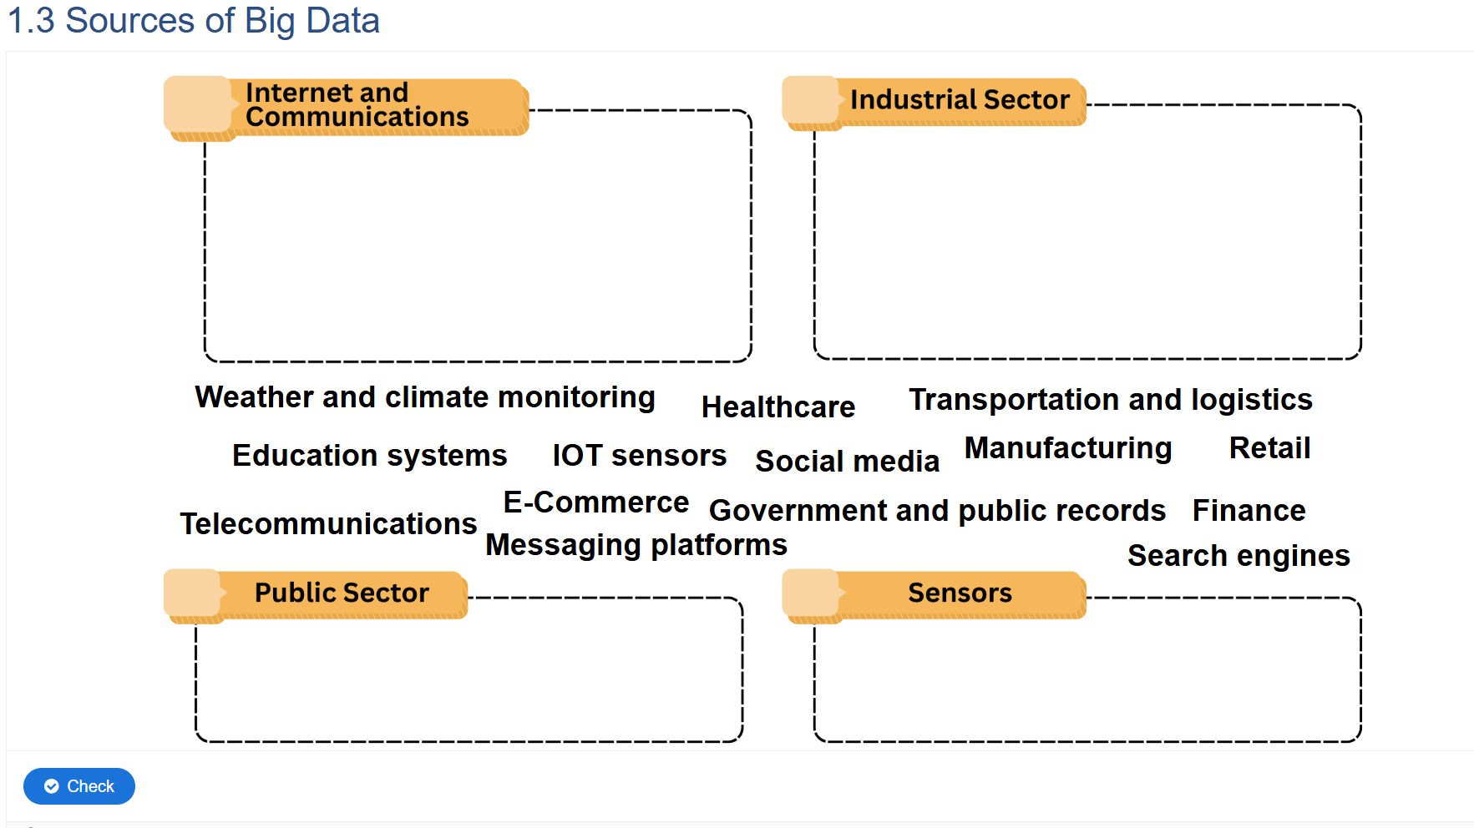
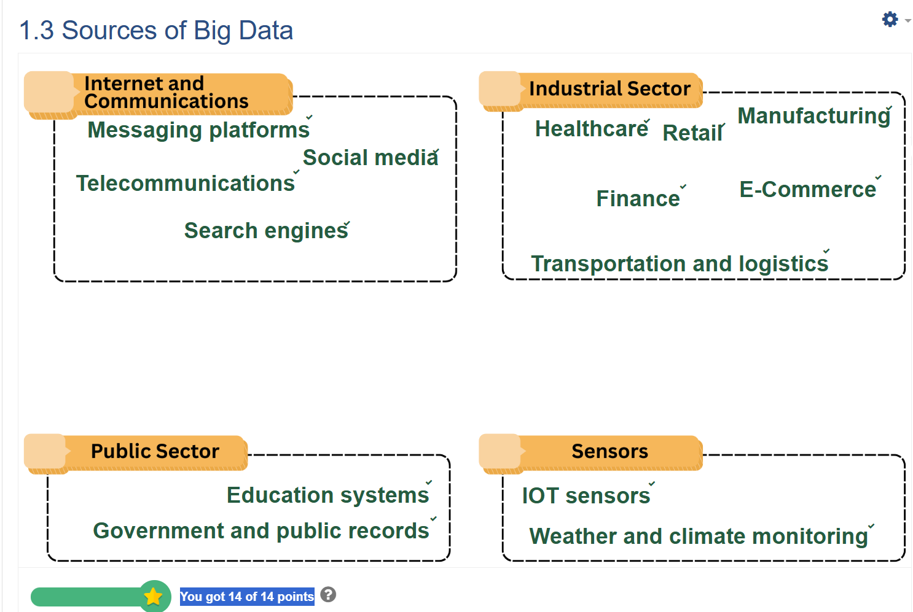
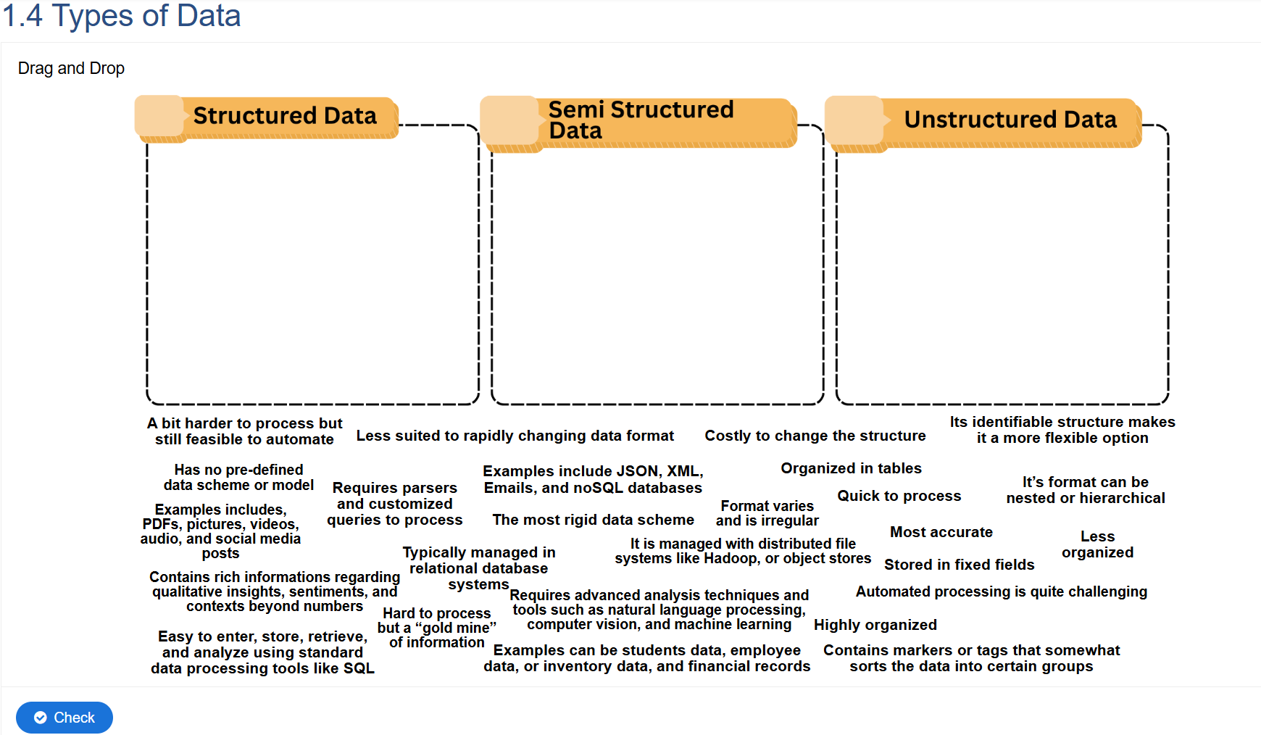
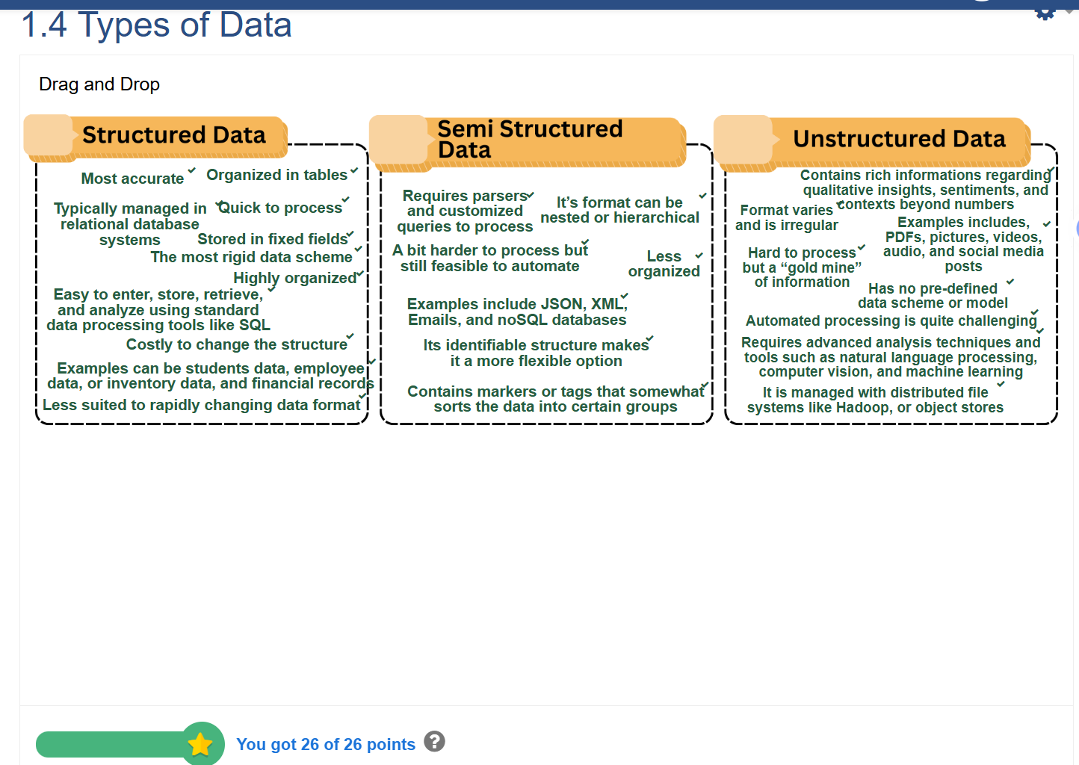

Interactive learning system
Chapter 2
Which of the following best describes surveys in data collection?
A. Data gathered through direct observation
B. Structured or unstructured responses collected from individuals
C. Automatically captured machine data from sensors
D. Pre-existing data collected from government portals
Answer: B
- What is the main advantage of using unstructured survey questions?
A. Easier data analysis
B. More reliable numerical data
C. Deeper insight into opinions and emotions
D. Fewer respondents required
Answer: C
- Observational data is most suitable when:
A. Respondents are unwilling to participate in surveys
B. Real-world behavior needs to be captured naturally
C. The study focuses only on numerical data
D. Data must come from government sources
Answer: B
- Transactional data usually originates from:
A. Questionnaires
B. Market purchases and online payments
C. Social media posts
D. Public databases
Answer: B
- Which of the following is an example of IoT data?
A. Temperature readings from smart thermostats
B. Tweets mentioning a brand
C. Interview transcripts
D. Historical census reports
Answer: A

Section 2.2 – How Data is Stored
Multiple Choice Questions (MCQ):
- Which type of database stores data in tables with rows and columns?
A. Data Lake
B. Cloud Storage
C. Relational Database (RDBMS)
D. NoSQL Database
Answer: C
- NoSQL databases are preferred for:
A. Handling only small datasets
B. Complex relationships between structured data
C. Managing unstructured and large-scale data
D. Storing data only on local servers
Answer: C
- A data warehouse is mainly used for:
A. Real-time data capture
B. Storing unprocessed raw data
C. Storing structured data for analytics and reporting
D. Archiving personal files
Answer: C
- Which storage system combines on-premises infrastructure with cloud resources?
A. Relational Database
B. Hybrid Storage
C. Data Lake
D. IoT Network
Answer: B
- Which of the following is a key feature of cloud storage?
A. Physical maintenance by the user
B. Accessible anywhere via the internet
C. Data cannot be shared
D. Limited scalability
Answer: B

Section 2.3 – Problems in Data Storage
Multiple Choice Questions (MCQ):
- Which of the following is not a common problem in data storage?
A. Data redundancy
B. Scalability issues
C. Real-time data analytics
D. Security risks
Answer: C
- What does data integrity refer to?
A. Keeping data clean, accurate, and consistent
B. Using only raw data
C. Storing backup copies of data
D. Data being stored on physical drives only
Answer: A
- A major environmental issue with large data centers is:
A. Lack of internet connection
B. Excessive energy consumption
C. Overuse of sensors
D. Poor data design
Answer: B
- Which of the following is a privacy-related concern in data storage?
A. Data encryption
B. Unauthorized access to sensitive information
C. Slow database queries
D. Outdated hardware
Answer: B
- What happens when data becomes outdated or irrelevant?
A. It increases data quality
B. It improves analysis accuracy
C. It reduces reliability and leads to wrong conclusions
D. It enhances model performance
Answer: C
Chapter 3
3.1 How Data is Processed

Multiple Choice Questions (MCQ):

Which of the following best defines data processing?
A. The act of collecting new data
B. The conversion of raw data into meaningful information
C. The deletion of irrelevant data
D. The distribution of processed data
Answer: B

Which is the first step in data processing?
A. Storage
B. Input
C. Output
D. Analysis
Answer: B

Real-time processing is most useful when:
A. Immediate responses are required
B. Data changes slowly over time
C. Batch updates are preferred
D. Data is stored offline
Answer: A

Which type of data processing handles large datasets at scheduled intervals?
A. Real-time processing
B. Distributed processing
C. Batch processing
D. Online processing
Answer: C

What is the main goal of data processing in Big Data and AI?
A. To reduce data volume
B. To transform data into useful, actionable information
C. To delete unnecessary data
D. To store data permanently
Answer: B

True or False Questions:

Data processing only occurs after data is analyzed. → False

Batch processing is faster than real-time processing in all situations. → False

Distributed processing uses multiple machines to handle data simultaneously. → True

Data processing helps clean, organize, and transform raw data. → True

The input stage of data processing involves interpreting the results. → False

3.2 How Data is Analyzed

Multiple Choice Questions (MCQ):

What is the main purpose of data analysis?
A. To delete irrelevant data
B. To extract patterns, trends, and insights from data
C. To store data securely
D. To collect data from users
Answer: B

Which type of analysis focuses on understanding what happened in the past?
A. Descriptive analysis
B. Predictive analysis
C. Diagnostic analysis
D. Prescriptive analysis
Answer: A

Predictive analysis is mainly used to:
A. Describe past data
B. Determine causes of past trends
C. Forecast future outcomes using historical data
D. Make no assumptions about data
Answer: C

Which type of analysis answers the question “Why did this happen?”
A. Prescriptive
B. Diagnostic
C. Descriptive
D. Predictive
Answer: B

Prescriptive analysis helps organizations by:
A. Predicting the future only
B. Recommending actions to achieve desired results
C. Showing only raw numbers
D. Describing events without context
Answer: B

True or False Questions:

Descriptive analysis focuses on the future rather than the past. → False

Diagnostic analysis helps identify the causes behind data trends. → True

Predictive analysis relies on historical data to make forecasts. → True

Prescriptive analysis provides actionable recommendations. → True

Data analysis is unrelated to decision-making in AI. → False

3.3 Tools for Data Analysis

Multiple Choice Questions (MCQ):

Which of the following is a statistical analysis tool?
A. Python
B. Tableau
C. SQL
D. SPSS
Answer: D

Visualization tools like Tableau and Power BI are primarily used for:
A. Storing data
B. Displaying data insights visually
C. Encrypting sensitive information
D. Collecting user data
Answer: B

Which tool is commonly used for machine learning and AI data analysis?
A. Excel
B. R
C. TensorFlow
D. PowerPoint
Answer: C

Which tool specializes in data querying and management?
A. SQL
B. Python
C. Tableau
D. Hadoop
Answer: A

What is the main purpose of data analysis tools?
A. To visualize, process, and interpret large datasets efficiently
B. To replace human analysts
C. To generate random data
D. To store backup files
Answer: A

True or False Questions:

Python and R are examples of programming tools for data analysis. → True

SQL is used mainly for creating visual graphs. → False

Data visualization helps simplify complex data into understandable visuals. → True

Machine learning tools like TensorFlow can analyze patterns automatically. → True

All data analysis tools serve the same purpose. → False

3.4 How Data is Interpreted

Multiple Choice Questions (MCQ):

What does data interpretation primarily involve?
A. Collecting new data
B. Explaining the meaning and implications of analyzed data
C. Cleaning unprocessed data
D. Storing backup information
Answer: B

Which interpretation method identifies cause-and-effect relationships?
A. Descriptive interpretation
B. Comparative interpretation
C. Causal interpretation
D. Inferential interpretation
Answer: C

Contextual interpretation focuses on:
A. Data accuracy only
B. Understanding data in relation to external factors
C. Predicting future outcomes
D. Analyzing only numerical information
Answer: B

What is the purpose of inferential interpretation?
A. To make general conclusions from sample data
B. To compare two datasets
C. To describe patterns without context
D. To store data permanently
Answer: A

Why is interpretation important in AI systems?
A. It gives meaning to data outputs and supports decision-making
B. It deletes raw data
C. It prevents data collection
D. It replaces human reasoning
Answer: A

True or False Questions:

Descriptive interpretation focuses on predicting future trends. → False

Comparative interpretation examines similarities and differences between datasets. → True

Contextual interpretation links data to real-world situations. → True

Causal interpretation is the same as descriptive interpretation. → False

Data interpretation helps convert numbers into meaningful insights. → True

Overview of Big Data chapter 4
Bolded answers are the correct ones.
1. Why is Big Data important for organizations?
a) It makes websites run faster
b) It helps businesses make data driven decisions and
discover trends
c) It replaces employees
d) It simplifies small scale operations

2. Which of the following is an advantage of Big Data?
a) Improved decision making through real time insights
b) Reduction of all operational costs
c) Guaranteed data accuracy
d) Simple data managemen.

3. One disadvantage of Big Data is:
a) High data accuracy
b) Low storage requirements
c) Security and privacy concerns
d) Ease of processing

4. Which technology is mainly used for data storage in Big Data environments?
a) Apache Hadoop Distributed File System (HDFS)
b) Tableau
c) Python
d) Power BI

5. Apache Spark is primarily used for:
a) Data visualization
b) Data processing and analytics
c) Data collection
d) Data encryption

6. What is the role of Apache NiFi in Big Data systems?
a) Managing and automating data flow between systems
b) Storing data in distributed servers
c) Encrypting sensitive information
d) Analyzing large datasets

7. Which of the following is a cloud computing platform commonly used for Big Data applications?
a) Hadoop
b) Amazon Web Services (AWS)
c) MySQL
d) Docker

8. Data Security Technologies in Big Data are used to:
a) Increase data generation speed
b) Protect data integrity and privacy from unauthorized access
c) Reduce data storage capacity
d) Remove redundant data

9. Apache Spark is primarily used for:
a) Data visualization
b) Data processing and analytics
c) Data collection
d) Data encryption

10. What is the role of Apache NiFi in Big Data systems?
a) Managing and automating data flow between systems
b) Storing data in distributed servers
c) Encrypting sensitive information
d) Analyzing large datasets

11. Which of the following is a cloud computing platform commonly used for Big Data applications?
a) Hadoop
b) Amazon Web Services (AWS)
c) MySQL
d) Docker

12. Data Security Technologies in Big Data are used to:
a) Increase data generation speed
b) Protect data integrity and privacy from unauthorized access
c) Reduce data storage capacity
d) Remove redundant data

13. Which of the following is a common application of Big Data in healthcare?
a) Streaming entertainment services
b) Predicting disease outbreaks and improving patient care
c) Tracking movie ratings
d) Reducing internet latency

14. In finance, Big Data is often used to:
a) Generate random numbers
b) Detect fraudulent transactions and predict market trends
c) Replace accounting systems
d) Block customer accounts

15. How is Big Data applied in marketing?
a) By guessing customer preferences
b) By analyzing consumer behavior to improve targeted advertising
c) By reducing advertisement budgets
d) By replacing customer service

16. In transportation, Big Data can be used to:
a) Predict traffic congestion and optimize routes
b) Increase toll prices
c) Replace public transport schedules
d) Control car emissions

Interactive learning system
Chapter 4

4.1 & 4.4 Importance of Big Data and its Application
Choose the correct statement. (Bolded answers are the correct ones.)
- Big data is mostly limited to large tech companies and rarely applied outside the private sector.
- Big data is used by many institutions, organisations, and businesses.

- Big data generally supports existing processes but rarely changes how organisations function.
- The application of big data has revolutionized how organisations operate everywhere in the world.

- By analysing big data, valuable information can be extracted, information that can be used to make more accurate predictions and better-suited decisions.
- Big data analysis often produces misleading trends and rarely improves predictive accuracy.

- Big data allows organisations, institutions, and researchers to gain insight on hidden patterns that would otherwise remain hidden in smaller databases.
- Insights from big data are usually redundant since small datasets already reveal most patterns.

- Financial fraud is too random to be detected using big data, making it mostly ineffective.
- Finance and banking data plays a key role in detecting fraudulent transactions and assessing financial risks.

- Big data in education primarily stores historical records and has little effect on teaching or learning outcomes.
- The education sector benefits from big data by enabling schools to track student performance, identify learning challenges, and design customized learning plans.

- In government and public services, big data supports the development of smart cities, better policy-making, and faster disaster response.
- Government services rarely benefit from big data, as traditional planning methods are sufficient.

- Real-time data from sensors is inconsistent and usually does not improve public services.
- By analyzing real-time data from sensors, cameras, and public records, governments can improve traffic management, waste collection, and emergency services.

- In transportation and logistics, big data helps optimize routes, manage fleets, and reduce delivery times by analyzing traffic patterns and weather data.
- Traffic and weather unpredictability makes big data ineffective in improving logistics.

- In social media and entertainment, platforms like Netflix, YouTube, and Spotify use big data to recommend personalized content and understand audience preferences.
- Content recommendation is mostly manual and not based on big data analysis.

- Farming decisions rely almost entirely on experience, and big data contributes minimally.
- Agriculture benefits from big data as it allows farmers to predict crop yields, monitor soil and weather conditions, and optimize resource use through smart farming technologies.

4.2 Advantages of big data
What are the advantages of big data (Bolded answers are the correct ones.)
- Helps with innovation.

- Improved efficiency.

- Helps with risk management.

- Helps with product development.

- Gives competitive advantage.

- Allows customer insight.

- High cost of implementation.

- Integration challenges.

- Better decision making.

- Allows personalization.

- Helps with fraud detection.

- Shortage of skilled professionals.

- Helps with cost reduction.

- Security issues.

- Data quality concerns.

- Data privacy issues.

- Complexity of data management.

- Ethical issues.

4.2 Disadvantage of big data
What are the disadvantages of big data ? (Bolded answers are the correct ones.)
- Helps with fraud detection.

- Helps with risk management.

- Data privacy issues.

- Better decision making.

- Shortage of skilled professionals.

- Security issues.

- Helps with innovation.

- Ethical issues.

- Improved efficiency.

- Allows customer insight.

- Helps with cost reduction.

- Integration challenges.

- High cost of implementation.

- Complexity of data management.

- Allows personalization.

- Helps with product development.

- Data quality concerns.

- Gives competitive advantage

4.3 Big Data Technologies
Identify the correct technology based on its description.
(Bolded answers are the correct ones.)

A distributed file system that stores massive amounts of data across many computers. (Hadoop)

A fast, in-memory data processing engine used for both batch and real-time analytics. (Apache Spark)

A real-time data streaming platform that acts like a high-performance message broker. (Apache Kafka)

A programming language popular for data manipulation and machine learning, with libraries like Pandas and Scikit-learn. (Python)

A business intelligence tool that turns data into interactive dashboards and reports. (Tableau)

A type of database designed to handle unstructured and semi-structured data. (No SQL Database)

A security method that converts data into a secret code to protect it from unauthorized access. (Encryption)

A cloud computing platform provided by Google, known for its data analytics and AI services. (Google Cloud)

Chapter 5
Overview of Connectionist AI

Section 5.1: Introduction: The 'Digital Brain'
1. In the "Digital Brain" analogy, what do the "weights" between artificial neurons represent?
a) The raw input data
b) The final output or answer
c) The strength of the connections, like roads between digital people
d) The learning algorithm itself
Answer : C
2. How does a Connectionist AI system primarily learn to perform a task, such as recognizing a cat?
a) By following a programmer's extensive list of written rules
b) By being shown many examples and adjusting its internal connections based on feedback
c) By processing a single, perfect instruction from a human expert
d) By randomly guessing until it gets the right answer
Answer : B
3. Which of the following is a key reason why the Connectionist AI approach is considered revolutionary?
a) It requires human experts to program all possible rules for a task.
b) It can learn automatically from examples without needing explicit programming for every rule.
c) It performs best with small, carefully curated datasets.
d) Its decisions are always easy for humans to interpret and explain.
Answer : B
4. What is the primary function of the "learning" process in the digital brain analogy?
a) To add more artificial neurons to the network
b) To adjust the strength of connections (weights) between neurons
c) To delete unnecessary data from the system
d) To convert all data into a single, unified format
Answer : B

Section 5.2: Connectionist AI vs Symbolic AI vs Behavior AI
5. According to section 5.2, which type of AI relies on predefined logical rules and facts to make clear, interpretable decisions?
a) Connectionist AI
b) Symbolic AI
c) Behavior-based AI
d) Generative AI
Answer : B
6. An AI that learns to play a video game through trial and error, constantly adapting its strategy based on rewards and penalties, is an example of:
a) Symbolic AI
b) Connectionist AI
c) Behavior-based AI
d) A hybrid system
Answer : C
7. Which AI approach is BEST suited for tasks involving unstructured data like images, speech, and text, where patterns are complex and messy?
a) Symbolic AI
b) Connectionist AI
c) Behavior-based AI
d) All are equally suited
Answer : B
8. Where is the knowledge primarily stored in a Symbolic AI system?
a) In the pattern of connection strengths between neurons
b) In a distributed representation across the network
c) In explicit rules and facts in a knowledge base
d) In the learned behaviors from environmental interaction
Answer : C
9. A medical expert system that uses a decision tree of "if-then" rules to diagnose diseases is a classic example of:
a) Connectionist AI
b) Symbolic AI
c) Behavior-based AI
d) Deep Learning
Answer : B

Section 5.3: Key Characteristics
10. What is the core concept behind "Teamwork Creates Intelligence" in Connectionist AI?
a) A single, powerful neuron is responsible for each complex concept.
b) Intelligence emerges from the collective activity of many simple, interconnected neurons.
c) AI systems work best when they collaborate with human teams.
d) Each neuron independently solves a small part of the problem.
Answer : B
11. The ability of a neural network to continue functioning reasonably well even if some of its neurons are damaged or fail is known as:
a) Data-Driven Improvement
b) Fault Tolerance
c) Real-World Complexity Handling
d) Parallel Processing
Answer : B
12. What does the "Data-Driven Improvement" characteristic of Connectionist AI imply?
a) The system's performance typically improves as it is trained on more data.
b) The system can only learn from perfectly clean and structured data.
c) The system's performance is fixed after the initial programming.
d) The system requires data to be manually labeled by thousands of engineers.
Answer : A
13. A voice assistant that can understand your command even when you are speaking in a noisy, crowded room demonstrates the Connectionist AI characteristic of:
a) Fault Tolerance
b) Data-Driven Improvement
c) Handling Real-World Complexity
d) Teamwork Power
Answer : C
14. The knowledge in a Connectionist AI system is stored in:
a) A single, dedicated "knowledge neuron" for each fact.
b) A centralized database of explicit rules.
c) The pattern of connection strengths (weights) across the entire network.
d) A library of pre-recorded responses.
Answer : C
15. Which characteristic explains why a facial recognition system becomes more accurate after analyzing millions of new user photos?
a) Fault Tolerance
b) Data-Driven Improvement
c) Teamwork Power
d) Handling Real-World Complexity
Answer : B

True/False Questions
16. True or False: Connectionist AI is inspired by the structure and function of the human brain.
Answer : True
17. True or False: In the "Digital Brain" analogy, learning is represented by building permanent, unchangeable roads between digital people.
Answer : False
18. True or False: Symbolic AI is generally better than Connectionist AI for tasks like image recognition and natural language processing.
Answer : False
19. True or False: Behavior-based AI learns primarily through interaction with its environment and feedback from its actions.
Answer : True
20. True or False: The concept of "Fault Tolerance" means that a neural network will never make a mistake.
Answer : False
21. True or False: A key characteristic of Connectionist AI is that it becomes less effective as the amount of training data increases.
Answer : False
22. True or False: Connectionist AI struggles with tasks that require clear, logical, step-by-step reasoning based on fixed rules.
Answer : True

Fill-in-the-Blank Questions
23. The type of AI that solves problems by following predefined rules and logical reasoning is known as ________ AI.
Answer : Symbolic
24. The revolutionary aspect of Connectionist AI is that it learns ________ from examples, rather than from programmed rules.
Answer : automatically / inductively
25. The characteristic where knowledge is stored across the entire network, not in one place, is called ________ representation.
Answer : distributed
26. When a neural network gets better at recognizing subtle patterns after being trained on millions of new images, it demonstrates ________.
Answer : Data-Driven Improvement
27. An AI that learns to navigate by bumping into walls and adjusting its path is using a ________-based approach.
Answer : behavior
Study Guide

Chapter 5: Overview of Connectionist AI - Quiz
Question 1: In the "Digital Brain" analogy, what do the "weights" between artificial neurons represent?
Answer: c) The strength of the connections, like roads between digital people
Question 2: How does a Connectionist AI system primarily learn to perform a task, such as recognizing a cat?
Answer: b) By being shown many examples and adjusting its internal connections based on feedback
Question 3: Which of the following is a key reason why the Connectionist AI approach is considered revolutionary?
Answer: b) It can learn automatically from examples without needing explicit programming for every rule.
Question 4: According to section 5.2, which type of AI relies on predefined logical rules and facts to make clear, interpretable decisions?
Answer: b) Symbolic AI
Question 5: An AI that learns to play a video game through trial and error, constantly adapting its strategy based on rewards and penalties, is an example of:
Answer: c) Behavior-based AI
Question 6: Which AI approach is BEST suited for tasks involving unstructured data like images, speech, and text, where patterns are complex and messy?
Answer: b) Connectionist AI
Question 7: What is the core concept behind "Teamwork Creates Intelligence" in Connectionist AI?
Answer: c) Intelligence emerges from the collective activity of many simple, interconnected neurons.
Question 8: The ability of a neural network to continue functioning reasonably well even if some of its neurons are damaged or fail is known as:
Answer: b) Fault Tolerance
Question 9: What does the "Data-Driven Improvement" characteristic of Connectionist AI imply?
Answer: a) The system's performance typically improves as it is trained on more data.
Question 10: A voice assistant that can understand your command even when you are speaking in a noisy, crowded room demonstrates the Connectionist AI characteristic of:
Answer: c) Handling Real-World Complexity

Chapter 6
Interactive learning system
6.1 What is a Neural Network?
Multiple Choice: What is the primary inspiration behind the structure of an artificial neural network?
a) The organization of a computer's CPU
b) The human brain and its biological neurons
c) The structure of a corporate hierarchy
d) The flow of electricity in a circuit
Answer: b) The human brain and its biological neurons

True/False: A single artificial neuron is capable of complex tasks like image recognition on its own.
Answer: False

6.2 Neuron
Fill in the Blanks: The output of a single artificial neuron is calculated by taking the weighted sum of its ______, adding a ______, and passing the result through an ______ function.
Answer: inputs, bias, activation

Matching: Match the part of a biological neuron to its analogous part in an artificial neuron.

1. Dendrite | A. Bias

2. Cell Body | B. Input

3. Axon Terminal | C. Activation Function & Summation

4. N/A | D. Output
Answer: 1-B, 2-C, 3-D, 4-A

6.3 Architectures Structure
Multiple Choice: Which neural network architecture is specifically designed to process grid-like data such as images by using convolutional layers to detect patterns like edges and shapes?
a) Feedforward Neural Network (FNN)
b) Recurrent Neural Network (RNN)
c) Convolutional Neural Network (CNN)
d) Radial Basis Function Network (RBFN)
Answer: c) Convolutional Neural Network (CNN)

Scenario: You need to build an AI that can predict the next word in a sentence, taking into account the words that came before it. Which neural network architecture is most suitable for this sequential data task?
a) Feedforward Neural Network (FNN)
b) Recurrent Neural Network (RNN)
c) Convolutional Neural Network (CNN)
Answer: b) Recurrent Neural Network (RNN)

Matching: Match the neural network type to its primary data flow characteristic.

1. FNN | A. Attention-based

2. RNN | B. One direction (Input → Output)

3. CNN | C. Sequential with loops

4. Transformer | D. Grid (2D)
Answer: 1-B, 2-C, 3-D, 4-A

6.4 Core Principle
Fill in the Blanks: The principle of _______________ means that knowledge in a neural network is stored as a pattern of activity across many neurons, not in a single one. This makes the network robust to failure.
Answer: Distributed Representation

Multiple Choice: What is the core principle that allows a trained neural network to correctly identify a new, unseen image of a cat after only being trained on other cat images?
a) Parallel Processing
b) Generalization
c) Non-linearity
d) Distributed Representation
Answer: b) Generalization

True/False: Activation functions like ReLU and Sigmoid are crucial because they introduce non-linearity, allowing the network to learn complex patterns.
Answer: True

6.5 Training Neural Network
Ordering: Put the steps of the neural network training process in the correct order.

A. Calculate Loss

B. Forward Propagation

C. Weight Update via Gradient Descent

D. Backpropagation

E. Initialize Weights
Correct Order: E, B, A, D, C

Multiple Choice: During training, what is the purpose of the "loss function"?
a) To initialize the weights with random values.
b) To measure how far the network's predictions are from the true answers.
c) To decide the architecture of the hidden layers.
d) To visualize the final output.
Answer: b) To measure how far the network's predictions are from the true answers.

Scenario Analysis: Your neural network model performs perfectly on the training data but poorly on new, unseen test data. What is this problem most likely called, and what is one common technique to fix it?

Problem: Overfitting

Solution: Use Dropout / Regularization / Get more training data.

Study Guide
1. What is the most basic processing unit in a neural network?
a) Layer
b) Neuron
c) Synapse
d) Weight

2. Which layer of a neural network is responsible for all computations and processing?
a) Input Layer
b) Output Layer
c) Hidden Layer
d) Convolutional Layer

3. In the analogy of a "digital city" for a neural network, what do the "weights" represent?
a) The citizens
b) The city rules
c) The roads between citizens
d) The buildings

4. What is the primary function of an activation function in a neuron?
a) To store the data
b) To decide whether the neuron should "fire"
c) To connect to the internet
d) To display the output

5. Which neural network architecture is specifically designed for processing sequential data like text or speech?
a) Feedforward Neural Network (FNN)
b) Convolutional Neural Network (CNN)
c) Recurrent Neural Network (RNN)
d) Radial Basis Function Network (RBFN)

6. What is the core mathematical operation a neuron performs on its inputs?
a) Division
b) Subtraction
c) Weighted Sum
d) Integration

7. Which type of neural network uses convolutional layers to detect patterns like edges and shapes in images?
a) FNN
b) CNN
c) RNN
d) Transformer

8. The process of "Backpropagation" is used to:
a) Collect more data
b) Calculate how much each weight contributed to the error
c) Initialize the weights randomly
d) Visualize the final output

9. What does the "bias" term in a neuron allow it to do?
a) Connect to more neurons
b) Shift the activation function left or right
c) Store long-term memory
d) Process data faster

10. The problem where a network memorizes training data but fails on new data is called:
a) Underfitting
b) Overfitting
c) Generalization
d) Parallel Processing

11. Which principle states that knowledge is stored as patterns across many neurons, not in a single one?
a) Parallel Processing
b) Distributed Representation
c) Generalization
d) Non-linearity

12. Which component measures the difference between the network's prediction and the true output?
a) Activation Function
b) Optimizer
c) Loss Function
d) Bias

13. What is the purpose of the "Optimizer" (like Gradient Descent) during training?
a) To collect the input data
b) To update weights to reduce loss
c) To draw the network architecture
d) To choose the activation function

14. Which architecture is known for using an "attention mechanism" and is the foundation for models like ChatGPT?
a) RNN
b) CNN
c) FNN
d) Transformer

15. The ability of a trained neural network to perform well on new, unseen data is called:
a) Overfitting
b) Memorization
c) Generalization
d) Parallel Processing

16. Which of these is a key characteristic of a Feedforward Neural Network (FNN)?
a) It has loops for memory.
b) Information moves only in one direction.
c) It uses convolutional filters.
d) It is only used for image data.

17. What does the "learning rate" hyperparameter control?
a) The size of the training dataset
b) How quickly the model updates its weights
c) The number of layers in the network
d) The type of activation function used

18. Which of the following is NOT a common activation function?
a) ReLU
b) Sigmoid
c) SQL
d) Tanh

19. The training phase where input data is passed from the input layer to the output layer is called:
a) Backpropagation
b) Forward Propagation
c) Weight Update
d) Initialization

20. What is the main advantage of "Parallel Processing" in neural networks?
a) It makes the network easier to draw.
b) It allows many calculations to happen at once, speeding up processing.
c) It reduces the need for data.
d) It eliminates the need for hidden layers.

Chapter 7
Deep Learning and Concept

Section 7.1: Machine Learning and Deep Learning
1. In the "Russian Doll" analogy for AI, what does the smallest, innermost doll represent?
a) Artificial Intelligence
b) Machine Learning
c) Deep Learning
d) Neural Networks
Answer : C
2. Which of the following is a key characteristic of Machine Learning (ML) compared to Deep Learning (DL)?
a) ML automatically discovers important features from raw data.
b) ML requires massive amounts of data to perform well.
c) ML often needs human experts to design and select relevant features.
d) ML primarily uses very deep neural networks with many layers.
Answer : C
3. What is a major advantage of Deep Learning over traditional Machine Learning?
a) It works effectively with very small datasets.
b) It requires less computational power and simpler hardware.
c) It can automatically learn hierarchical features from raw data.
d) Its models are always simpler and easier to interpret.
Answer : C
4. Which field would be MOST suited for a Deep Learning approach?
a) Analyzing a small spreadsheet of 100 customer records.
b) Classifying millions of high-resolution images into thousands of categories.
c) Implementing a simple "if-then" rule-based system for a thermostat.
d) Calculating the average sales from a structured database table.
Answer : B
5. A spam filter that relies on human-engineered features like "presence of certain keywords" is typically an example of:
a) Deep Learning
b) Machine Learning
c) Symbolic AI
d) Behavior-based AI
Answer : B

Section 7.2: Advanced Concepts
6. The "Memorizer Problem" in deep learning is more formally known as:
a) Underfitting
b) Overfitting
c) Generalization
d) Gradient Descent
Answer : B
7. What happens when a model is "overfitting" the training data?
a) It performs well on training data but poorly on new, unseen data.
b) It performs poorly on both training data and new data.
c) It has not been trained for a sufficient number of epochs.
d) It is too simple to capture the patterns in the data.
Answer : A
8. The "Under-Achiever Problem" in deep learning, where a model is too simple to learn the underlying pattern, is called:
a) Overfitting
b) Underfitting
c) Regularization
d) Optimization
Answer : B
9. Which of the following is a common technique to prevent overfitting?
a) Using a more complex model with more layers
b) Stopping training early (Early Stopping)
c) Increasing the learning rate
d) Training on a smaller dataset
Answer : B
10. Settings that control the learning process itself, such as "learning rate" and "number of layers," are known as:
a) Weights and Biases
b) Model Parameters
c) Hyperparameters
d) Activation Functions
Answer : C
11. What is the purpose of the "learning rate" hyperparameter?
a) It determines the size of the training dataset.
b) It controls how quickly the model updates its weights during training.
c) It defines the number of layers in the neural network.
d) It selects which activation function to use.
Answer : B
12. The technique of randomly turning off a subset of neurons during training to prevent overfitting is called:
a) Early Stopping
b) Dropout
c) Batch Normalization
d) Data Augmentation
Answer : B
13. Which of the following is a "Regularization" technique?
a) Increasing the model complexity
b) Adding a penalty for large weights to the loss function (L2 Regularization)
c) Using a very high learning rate
d) Training the model for more epochs
Answer : B
14. What is the primary goal of "Hyperparameter Tuning"?
a) To adjust the weights and biases of the model.
b) To find the optimal settings that control the learning process for the best performance.
c) To clean and preprocess the input data.
d) To visualize the model's decision-making process.
Answer : B
15. A model that has learned the noise and specific details of the training set instead of the generalizable patterns is suffering from:
a) Underfitting
b) Optimal Fitting
c) Overfitting
d) Perfect Fitting
Answer : C

True/False Questions
16. True or False: Deep Learning is a subset of Machine Learning, which is itself a subset of Artificial Intelligence.
Answer : True
17. True or False: Machine Learning models typically require larger datasets than Deep Learning models to achieve good performance.
Answer : False
18. True or False: "Underfitting" occurs when a model is too complex and learns the training data too well.
Answer : False
19. True or False: "Dropout" is a hyperparameter that controls the speed of learning.
Answer : False
20. True or False: The process of finding the best values for hyperparameters like learning rate and batch size is called "Hyperparameter Tuning."
Answer : True
21. True or False: "Early Stopping" is a regularization technique that halts training when performance on a validation set starts to degrade, to prevent overfitting.
Answer : True
22. True or False: A model with high bias is another way of saying the model is overfitting.
Answer : False

Fill-in-the-Blank Questions
23. The problem where a model fails to learn the underlying trend in the training data itself is called ________.
Answer : Underfitting
24. Techniques like Dropout and L1/L2 regularization are used to prevent ________.
Answer : Overfitting
25. The settings that control the learning process, such as the learning rate and number of hidden layers, are called ________.
Answer : Hyperparameters
26. A student who memorizes textbook answers but fails a real-world exam is an analogy for the deep learning problem of ________.
Answer : Overfitting
27. ________ is a regularization method that involves randomly ignoring neurons during the training phase.
Answer : Dropout
Study Guide

Chapter 7: Deep Learning and Concept - Quiz
Question 1: In the "Russian Doll" analogy for AI, what does the smallest, innermost doll represent?
Answer: c) Deep Learning
Question 2: Which of the following is a key characteristic of Machine Learning (ML) compared to Deep Learning (DL)?
Answer: c) ML often needs human experts to design and select relevant features.
Question 3: What is a major advantage of Deep Learning over traditional Machine Learning?
Answer: c) It can automatically learn hierarchical features from raw data.
Question 4: The "Memorizer Problem" in deep learning is more formally known as:
Answer: b) Overfitting
Question 5: What happens when a model is "overfitting" the training data?
Answer: a) It performs well on training data but poorly on new, unseen data.
Question 6: The "Under-Achiever Problem" in deep learning, where a model is too simple to learn the underlying pattern, is called:
Answer: b) Underfitting
Question 7: Which of the following is a common technique to prevent overfitting?
Answer: b) Stopping training early (Early Stopping)
Question 8: Settings that control the learning process itself, such as "learning rate" and "number of layers," are known as:
Answer: c) Hyperparameters
Question 9: What is the purpose of the "learning rate" hyperparameter?
Answer: b) It controls how quickly the model updates its weights during training.
Question 10: The technique of randomly turning off a subset of neurons during training to prevent overfitting is called:
Answer: b) Dropout

Chapter 8
Key Application

Section 8.1: Applications
1. Which application of Connectionist AI is used by self-driving cars to identify traffic signs, pedestrians, and other vehicles?
a) Natural Language Processing (NLP)
b) Computer Vision
c) Audio and Speech Processing
d) Recommendation Systems
Answer : B
2. Virtual assistants like Siri and Alexa that process voice commands and questions primarily rely on:
a) Computer Vision
b) Natural Language Processing (NLP)
c) Robotic Process Automation
d) Financial Algorithmic Trading
Answer : B
3. What technology do music streaming services like Spotify use to recommend new songs you might like?
a) Computer Vision
b) Fraud Detection Systems
c) Audio Analysis & Recommendation Systems
d) Supply Chain Logistics
Answer : C
4. In finance, Connectionist AI is crucial for:
a) Designing bank buildings
b) Detecting fraudulent credit card transactions
c) Printing currency
d) Setting interest rates manually
Answer : B
5. Which application involves converting spoken language into written text?
a) Sentiment Analysis
b) Machine Translation
c) Speech Recognition
d) Content Generation
Answer : C
6. AI that creates art, music, and writing falls under which broad application category?
a) Business and Finance
b) Healthcare Diagnostics
c) Entertainment and Creativity
d) Autonomous Systems
Answer : C

Section 8.2: Advantage and Disadvantage
7. A key advantage of Connectionist AI is its ability to:
a) Operate effectively with very small amounts of data.
b) Automatically learn relevant features from raw, unstructured data.
c) Always provide clear and easy-to-interpret reasons for its decisions.
d) Run on low-power devices without specialized hardware.
Answer : B
8. What is the "Black Box Problem" in Connectionist AI?
a) The high cost of the physical hardware required.
b) The difficulty in understanding how the model arrived at a specific decision.
c) The need for data to be stored in black-colored servers.
d) The tendency of models to work only in dark environments.
Answer : B
9. A major disadvantage of Deep Learning models is that they are:
a) Not suitable for pattern recognition tasks.
b) Computationally intensive and require powerful hardware like GPUs.
c) Unable to handle unstructured data like images and text.
d) Only capable of solving simple, linear problems.
Answer : B
10. Connectionist AI models can sometimes amplify societal biases because they:
a) Are programmed to be unfair.
b) Learn from data that may contain existing human biases.
c) Use random number generators that are inherently biased.
d) Ignore the data they are trained on.
Answer : B
11. Which of the following is an advantage of Connectionist AI?
a) Low computational cost
b) Transparency in decision-making
c) Superior performance in complex pattern recognition
d) Immunity to biased data
Answer : C
12. The fact that a deep learning model's performance improves as it is fed more data is known as:
a) The Black Box Problem
b) Computational Intensity
c) Scaling with Data
d) Bias Amplification
Answer : C

Section 8.3: Tools and Framework for Deep Learning
13. Which deep learning framework is known for its industrial-strength capabilities and is widely used in production systems, but has a steeper learning curve?
a) PyTorch
b) TensorFlow
c) Keras
d) Scikit-learn
Answer : B
14. Which framework, developed by Facebook's AI Research lab, is praised for its Pythonic syntax and dynamic computation graphs, making it popular for research?
a) TensorFlow
b) Keras
c) PyTorch
d) MXNet
Answer : C
15. What is Keras primarily known as?
a) A low-level programming language for hardware control.
b) A high-level API that simplifies the building of neural networks, often running on top of TensorFlow.
c) A database management system for big data.
d) A cloud computing platform.
Answer : B
16. A researcher who wants to quickly prototype a new neural network architecture with an easy-to-use interface would likely choose:
a) Caffe
b) TensorFlow (without Keras)
c) Keras
d) Assembly Language
Answer : C

Section 8.4: Challenges and Solution
17. What is a common challenge when labeled training data is insufficient?
a) High Computational Cost
b) Data Scarcity
c) The Black Box Problem
d) Model Overfitting
Answer : B
18. Which technique helps address the challenge of Data Scarcity by creating modified versions of existing training data?
a) Using more powerful GPUs
b) Data Augmentation
c) Early Stopping
d) Explainable AI (XAI)
Answer : B
19. The high computational cost of training deep learning models can be mitigated by using:
a) Larger, more complex models
b) Cloud computing services
c) Stopping the training process very early
d) Smaller datasets
Answer : B
20. To address the "Black Box Problem" and make AI decisions more interpretable, researchers are developing:
a) Larger datasets
b) Explainable AI (XAI) techniques
c) More powerful GPUs
d) Faster data storage solutions
Answer : B
21. Which of the following is a solution to prevent models from memorizing training data (Overfitting)?
a) Using a smaller model capacity
b) Applying regularization methods like Dropout
c) Training for more epochs
d) Using a higher learning rate
Answer : B
22. To combat bias in AI models, it is crucial to:
a) Use the fastest available processors.
b) Collect and use diverse, representative training data.
c) Always use the most complex model available.
d) Hide the model's decisions from users.
Answer : B

True/False Questions
23. True or False: Connectionist AI is excellent for pattern recognition but often struggles with tasks that require logical, rule-based reasoning.
Answer : True
24. True or False: The "Black Box Problem" refers to the high energy consumption of AI data centers.
Answer : False
25. True or False: TensorFlow and PyTorch are both popular open-source frameworks for deep learning.
Answer : True
26. True or False: Data Augmentation is a technique used to reduce the computational cost of training.
Answer : False
27. True or False: If a deep learning model is biased, the problem can always be fixed by training it for more epochs.
Answer : False
28. True or False Keras is a high-level API that can run on top of other frameworks like TensorFlow to simplify model building.
Answer : True

Fill-in-the-Blank Questions
29. The application of AI to understand and generate human language is called ________.
Answer : Natural Language Processing (NLP)
30. The term used to describe the inability to easily understand how an AI model made a decision is the ________ Problem.
Answer : Black Box
31. ________ is a deep learning framework highly popular in research for its flexibility and ease of use.
Answer : PyTorch
32. Techniques like collecting more diverse data and using bias detection tools are used to address the challenge of AI ________.
Answer : Bias (and Fairness)
33. Using cloud services like AWS or Google Cloud is a common solution to the challenge of ________.
Answer : High Computational Cost
Study Guide

Chapter 8: Key Application - Quiz
Question 1: Which application of Connectionist AI is used by self-driving cars to identify traffic signs, pedestrians, and other vehicles?
Answer: b) Computer Vision
Question 2: Virtual assistants like Siri and Alexa that process voice commands and questions primarily rely on:
Answer: b) Natural Language Processing (NLP)
Question 3: What technology do music streaming services like Spotify use to recommend new songs you might like?
Answer: c) Audio Analysis & Recommendation Systems
Question 4: In finance, Connectionist AI is crucial for:
Answer: b) Detecting fraudulent credit card transactions
Question 5: A key advantage of Connectionist AI is its ability to:
Answer: b) Automatically learn relevant features from raw, unstructured data.
Question 6: What is the "Black Box Problem" in Connectionist AI?
Answer: b) The difficulty in understanding how the model arrived at a specific decision.
Question 7: A major disadvantage of Deep Learning models is that they are:
Answer: b) Computationally intensive and require powerful hardware like GPUs.
Question 8: Which deep learning framework is known for its industrial-strength capabilities and is widely used in production systems, but has a steeper learning curve?
Answer: b) TensorFlow
Question 9: Which framework, developed by Facebook's AI Research lab, is praised for its Pythonic syntax and dynamic computation graphs, making it popular for research?
Answer: c) PyTorch
Question 10: What is a common challenge when labeled training data is insufficient?
Answer: b) Data Scarcity

Study Guide
Chapter 2
1. Which of the following is a key disadvantage of surveys and questionnaires?
A. Time-consuming and expensive to collect
B. Responses may be biased or inaccurate
C. Highly structured and accurate
D. Real-time and continuous monitoring
2. Observational data is particularly useful in AI systems because it:
A. Provides structured transaction records
B. Ensures data is free and open to the public
C. Is easy to distribute and collect from large audiences
D. Captures real-world, unbiased behaviors and events
3. Which type of data is generated automatically from purchases, payments, or bookings?
A. Sensor and IoT data
B. Web and social media data
C. Transactional data
D. Experimental data
4. A major disadvantage of web and social media data is that:
A. It is highly structured and accurate
B. Data overload can occur
C. Ethical and privacy risks are present, and data may be noisy
D. It provides limited insight into customer behavior
5. Public and open data sources are particularly useful because:
A. They are expensive but highly accurate
B. They require no preprocessing or validation
C. They are free, accessible, and encourage collaboration
D. They capture real-time sensor data
6. Which type of data is continuous, real-time, and collected from devices like smartwatches or industrial machines?
A. Transactional data
B. Sensor and IoT data
C. Public and open data sources
D. Surveys and questionnaires
7. Experimental data is especially valuable in AI because it:
A. Reflects large-scale public behavior in real time
B. Provides high accuracy and allows clear cause-andeffect analysis
C. Is automatically collected from online transactions
D. Is easy to distribute to large audiences
8. (True/False) Excessive redundancy in storage improves data access speed and reduces costs.
9. Which of the following is an environmental concern related to modern data storage systems?
A. High energy consumption and electronic waste
B. Poor access control and authentication
C. Difficulty maintaining data synchronization
D. Cost of cloud subscriptions
10. Which of the following best describes a scalability challenge in data storage?
A. Difficulty encrypting sensitive information
B. Duplicate copies of the same data
C. Loss of data integrity during backups
D. Struggling to handle exponential data growth efficiently
11. (True/False) Maintaining data consistency means ensuring that all copies of data across different systems are identical and up to date.
12. Which is a common cause of security and privacy risks in data storage systems?
A. Using green energy-powered data centers
B. Misconfigured cloud storage or weak encryption
C. Reducing data redundancy through deduplication
D. Implementing strict data governance policies
13. Relational Databases (RDBMS) are best suited for storing unstructured data such as social media posts and images. True or False?
14. NoSQL Databases can handle large volumes of semistructured or unstructured data and allow flexible schemas. True or False?
15. Data Warehouses are optimized for real-time transaction processing rather than analytical reporting. True or False?
16. Data Lakes store raw data in its native format, making them ideal for AI and machine learning applications. True or False?
17. Cloud Storage requires a stable internet connection to access data stored remotely, and it allows users to scale storage as needed. True or False
18. Hybrid Storage combines on-premises and cloud storage to improve flexibility, but it can introduce complex management challenges. True or False?
Chapter 3
1. (True/False) Descriptive interpretation focuses on explaining why something happened using cause-and-effect relationships.
2. (True/False) Comparative interpretation helps identify differences and similarities between two or more datasets.
3. (True/False) Inferential interpretation uses a sample of data to make generalizations or predictions about a larger population.
4. (True/False) Contextual interpretation ignores external factors and focuses only on the data itself.
5. (True/False) Causal interpretation aims to discover the reasons why an event or pattern occurs in the data.
6. (True/False) Descriptive and comparative interpretations are mainly used for summarizing and comparing, while inferential, contextual, and causal are used for explaining and predicting.
7. (True/False) Descriptive analysis in big data helps companies understand what has happened by summarizing large volumes of historical sales data.
8. (True/False) Diagnostic analysis uses neural networks to predict future outcomes based on past data patterns.
9. (True/False) In a retail company, predictive analysis powered by connectionist AI can forecast future sales trends by learning from previous customer behaviors. Answer: True
10. (True/False) Prescriptive analysis in big data provides explanations for past sales performance but does not offer recommendations for future actions.
11. (True/False) Connectionist AI, such as deep learning models, can enhance predictive and prescriptive analytics by finding hidden patterns in massive datasets that humans might miss.
12. Which tool is primarily used for distributed storage and batch data processing in Big Data?
A. TensorFlow
B. Hadoop
C. Tableau
D. Scikit-learn
13. What makes Apache Spark different from Hadoop?
A. It can only process data in batches
B. It is slower but easier to use
C. It processes data in real-time using in-memory computing
D. It cannot handle streaming data
14. Which tool is mainly used for building and training neural networks in connectionist AI?
A. Tableau
B. Pandas
C. TensorFlow
D. Apache Spark
15. What is the main purpose of Tableau in data analysis?
A. Data visualization and creating interactive dashboards
B. Data storage and management
C. Training deep learning models
D. Cleaning and transforming datasets
16. Which data processing method handles data all at once after it has been collected?
A. Real-time processing
B. Batch processing
C. Interactive processing
D. Distributed processing Review Questions
17. (True/False) Real-time processing analyzes data immediately as it is generated. 18. Which processing type is ideal for immediate detection of fraud or anomalies?
A. Batch processing
B. Interactive processing
C. Real-time (stream) processing
D. Distributed processing
19. (True/False) Batch processing is ideal when instant insights are required.

Chapter 9
Interactive learning system
Chapter 9: The Link Between Big Data and AI
True or False Questions
Connectionist AI can perform effectively with very small amounts of data; Big Data is not essential for it.

Answer: False

Big Data provides the "fuel" of massive datasets, while Connectionist AI acts as the "engine" that processes it.

Answer: True

The relationship between Big Data and AI is a one-way street: Big Data improves AI, but AI does not help in analyzing Big Data.

Answer: False

A key part of the link is a feedback loop where better AI models lead to better analysis, which in turn helps create better data.

Answer: True

The primary role of Connectionist AI in this relationship is to provide cheaper data storage solutions.

Answer: False

Multiple Choice Questions (Single Select)
Why is Big Data crucial for training effective Connectionist AI models?
a) It provides the rules and logic for the AI to follow.
b) It reduces the need for powerful computing hardware like GPUs.
c) Large, diverse datasets help the model learn complex and accurate patterns.
d) It simplifies the AI's architecture, making it easier to build.

Answer: c) Large, diverse datasets help the model learn complex and accurate patterns.

How does Connectionist AI help in analyzing Big Data?
a) By automatically detecting trends, classifying information, and making predictions from massive datasets.
b) By manually sorting data into structured tables and spreadsheets.
c) By compressing data to reduce storage costs.
d) By replacing traditional databases like SQL and NoSQL.

Answer: a) By automatically detecting trends, classifying information, and making predictions from massive datasets.

In the analogy used in the study guide, Big Data is to fuel as Connectionist AI is to the:
a) Driver
b) Engine
c) Roadmap
d) Exhaust

Answer: b) Engine

Which of the following is an example of the "feedback loop" between Big Data and AI?
a) AI models are trained once and never updated.
b) Better data leads to better AI, which then helps analyze data to gain even deeper insights.
c) Big Data is used only for storage, and AI is used only for analysis, with no interaction.
d) AI becomes less accurate as it processes more data.

Answer: b) Better data leads to better AI, which then helps analyze data to gain even deeper insights.

In which application would the combination of Big Data and Connectionist AI be LEAST directly necessary?
a) Analyzing millions of medical images to detect early-stage diseases.
b) Using a dataset of financial transactions to build a real-time fraud detection system.
c) Storing a list of employee names and IDs in a small company's HR database.
d) Powering a social media platform's content recommendation engine.

Answer: c) Storing a list of employee names and IDs in a small company's HR database. (This is a traditional, small-scale data task that doesn't require the power of Big Data or complex AI).

What is the core relationship between Big Data and Connectionist AI?
a) They are competing technologies.
b) Connectionist AI depends on Big Data to learn, and Big Data depends on AI to make sense of it.
c) Big Data is a subfield of Connectionist AI.
d) Their relationship is purely theoretical with no practical applications.

Answer: b) Connectionist AI depends on Big Data to learn, and Big Data depends on AI to make sense of it.

Study Guide
1. How is Big Data often described in its relationship with Connectionist AI?
a) The Engine
b) The Fuel
c) The Output
d) The Blueprint

2. What is the primary role of Connectionist AI in this relationship?
a) To store massive amounts of data
b) To learn complex patterns and make predictions from data
c) To generate the 5 V's of data
d) To replace all traditional databases

3. Which of the following is a result of the synergy between Big Data and AI?
a) Smarter, data-driven systems
b) Smaller, more compact datasets
c) Less need for computer hardware
d) Elimination of data privacy concerns

4. In the context of this relationship, what does the "feedback loop" refer to?
a) Big Data improves AI, and better AI helps analyze more Big Data.
b) AI creates data, and then data deletes AI.
c) Users give feedback to improve data storage.
d) Data is fed back into the system to slow it down.

5. Which application is a prime example of Big Data and Connectionist AI working together in healthcare?
a) Sending appointment reminders
b) Designing hospital buildings
c) Analyzing medical images to detect disease
d) Managing staff payroll

6. In e-commerce, how does AI use Big Data?
a) To design product packaging
b) To create personalized product recommendations
c) To set up physical stores
d) To manufacture products faster

7. For an autonomous vehicle, what does the "Big Data" primarily consist of?
a) Music playlists
b) Huge datasets of images, videos, and sensor readings
c) Driver's personal information
d) Maps from the 1990s

8. What key property of Big Data ensures that AI models have enough examples to learn from?
a) Velocity
b) Volume
c) Variety
d) Veracity

9. In finance, AI models trained on Big Data are crucial for:
a) Designing bank logos
b) Printing paper money
c) Detecting fraudulent transactions
d) Hiring bank tellers

10. Which of the 5 V's of Big Data refers to the diversity of data types (text, images, etc.)?
a) Volume
b) Velocity
c) Variety
d) Value

11. How does Connectionist AI help make sense of Big Data?
a) By automatically detecting trends and classifying data
b) By deleting redundant data
c) By slowing down data processing for better accuracy
d) By converting all data into paper reports

12. What is the "engine" in the "Big Data is fuel, AI is the engine" analogy?
a) The Cloud
b) Connectionist AI
c) Data Scientists
d) The Internet

13. In social media, the combination of Big Data and AI is used for:
a) Sending physical mail
b) Content moderation and sentiment analysis
c) Building satellite dishes
d) Designing smartphone hardware

14. Which V of Big Data refers to the speed at which data is generated and processed?
a) Volume
b) Velocity
c) Veracity
d) Value

15. The relationship between Big Data and Connectionist AI is best described as:
a) Independent
b) Mutually dependent
c) Competitive
d) Identical

16. What does AI add to the "Value" of Big Data?
a) It increases the storage cost.
b) It extracts meaningful insights and predictions from it.
c) It makes data more difficult to access.
d) It converts all data into a single format.

17. For a "Smart City" application, what might be the source of its Big Data?
a) Sensors monitoring traffic and energy use
b) Ancient scrolls in a library
c) Weather reports from 50 years ago
d) A single traffic camera

18. Why is the "Veracity" (accuracy) of Big Data important for AI?
a) Because AI models trained on inaccurate data will produce flawed results.
b) Because it makes data look more professional.
c) Because it is the least important V.
d) Because it determines the color of data visualizations.

19. The cycle where better AI models lead to the analysis of more complex data, which in turn creates even better AI models, is known as:
a) A vicious cycle
b) A feedback loop
c) A one-way street
d) A dead end

20. Which statement best summarizes the link between Big Data and Connectionist AI?
a) Big Data is obsolete without AI.
b) AI cannot exist without Big Data.
c) Big Data provides the raw material for AI to learn from, and AI provides the tools to extract value from Big Data.
d) They are two completely separate fields of study.

